RentMojo

By

Navjot kaur

Level-6

Final Project

Table of Contents

Project Proposal 3

Goals and Objectives 3

Project Scope 3

Project Specifications 3

Target Audience 3

Project Deliverables 4

Resource Requirements 4

Project Tasks and Milestones 4

Project Assumptions 5

Project Report 5

Detail Design 6

Home Page 6

Registration Page 6

Login Page 7

All Order History Admin View 7

Product Page Admin View 8

All Product Visitor View 8

Sub Type Visitor View 9

Product Details Page Visitor View 9

Project Testing 10

User Manual 10

Summary 10

System Configuration 10

User Access Levels 10

# 

# Project Proposal

## Goals and Objectives

The main goal or aim of the project is to implement an online web application named “RentoMojo”. The main purpose of the application is help people to find items related to different section for rent purpose. In this application there are two types of users- admin and registered visitor. Admin has different functionalities as compare to registered visitor. Admin can add, edit, delete and check details of all types, sub types, and products. Admin can delete and check details of the product orders. Also, user can place order of required product for rent.

## Project Scope

The scope of this project is to implement an app named “RentoMojo” with the help of which user can find any items and order for rent them. The duration of the project is 20 working days which is equals to 4 weeks.

## Project Specifications

* Admin login/logout
* Add, edit, delete and check details of types or section by admin.
* Admin can delete, edit and check sub types or sub section.
* Admin can delete and check product details.
* Admin can register new admins.
* Registered Visitor can login/logout.
* New Visitor can register.
* Registered Visitor can order the product available on site.

## Target Audience

The target audience for this project is the people who travel lot and for them it is hard to maintain items movement, so they rent the desired item from web site. The age can go from 5 plus to 100 plus.

## Project Deliverables

The deliverables of the project are:

|  |  |
| --- | --- |
| **Deliverable** | **Description** |
| Final Report | This will be the final report of the project. |
| Coding | The executable code of the project will go under this. |
| Documentation | This portrays the documentation of the project. |
| Testing | All the test details will be covered in this part. |

## Resource Requirements

* Windows Operating System.
* Microsoft word for documentation.
* Asp.net MVC Framework
* 64-bit Processor and 4 GB or more RAM
* Identity framework- ASP

## Project Tasks and Milestones

|  |  |  |  |  |
| --- | --- | --- | --- | --- |
| **Tasks** | **Week-1** | **Week-2** | **Week-3** | **Week-4** |
| Brainstorming and analysis |  |  |  |  |
| Planning and initial meeting Project Proposal document. |  |  |  |  |
| Database Design and UI Design |  |  |  |  |
| Identity framework implementation |  |  |  |  |
| Coding for admin and reporter |  |  |  |  |
| Testing |  |  |  |  |
| Final Documentation and closing |  |  |  |  |

## Project Assumptions

Following are the assumption made while implementing the project:

* One admin and registered visitor will be registered by default.
* Application will be free and open source.

# Project Report

#### Functional and Non-Functional

|  |  |
| --- | --- |
| Users | Functional |
| Admin | * Login/logout * Register new admins * Admin can add, edit, delete, check details for types. * Admin can edit, delete and check details for sub types. * Admin can delete and check details for the product. |
| Customer | * Can view details of types, sub types, and products * Can order the product for rent * New customers can register for free. * Login using valid credentials |
|  | Non- Functional |
|  | * High speed * Fast Loading time * High performance and security * All browsers compatibility. |

## Detail Design

### 

### Home Page

The main landing page of the application. On navigation bar options are- Home, Products, Types Link, Register, Login.

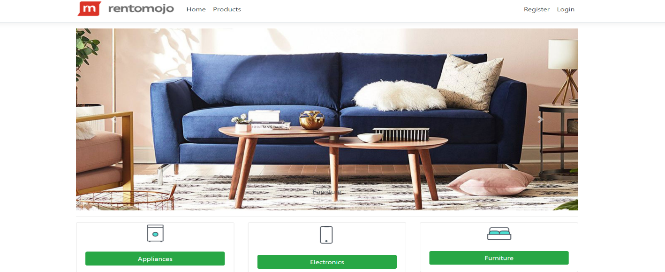

### 

### Registration Page

With the help of this page, new registered visitor can sign up for the app

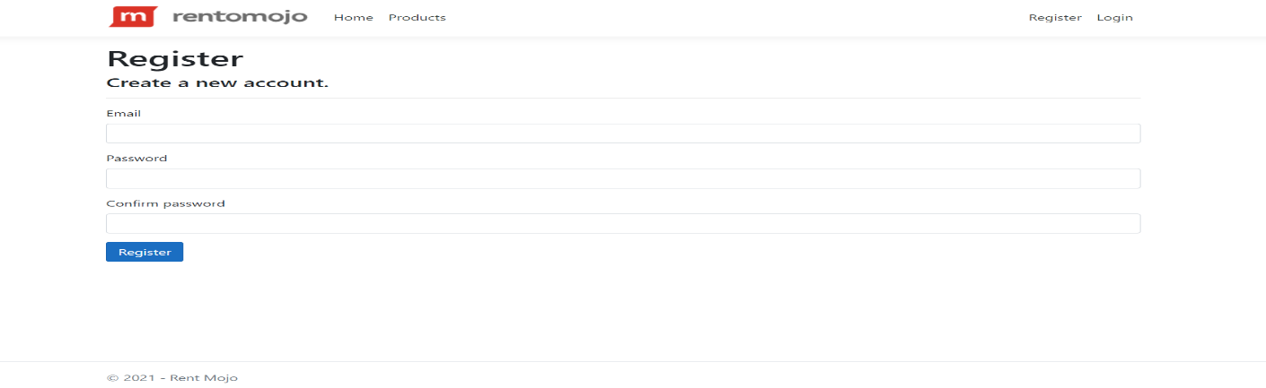

### 

### Login Page

With the help of this page, registered visitor and admin can login to the application using their valid credentials.

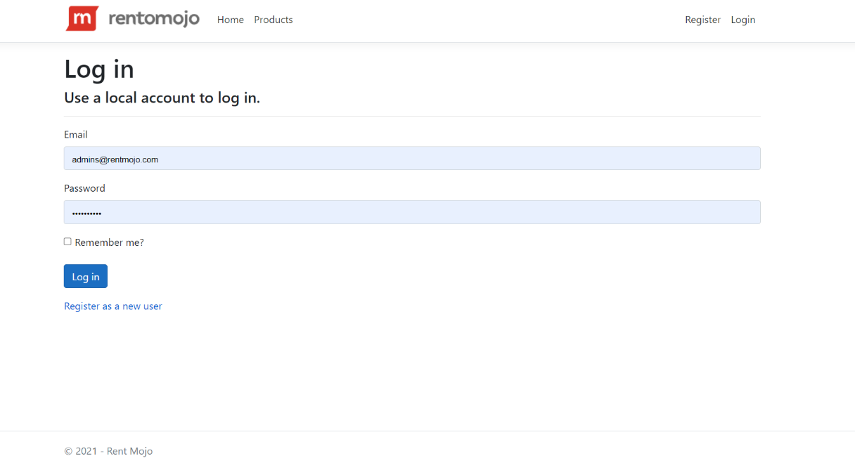

### 

### All Order History Admin View

This page highlights all the Order History available on the application. Admin can delete and check details of the existing ones.

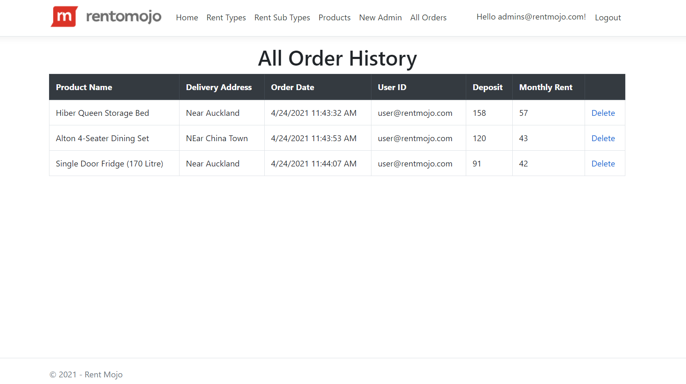

### Product Page Admin View

With the help of this page admin can manage the products by editing, deleting and checking their details.

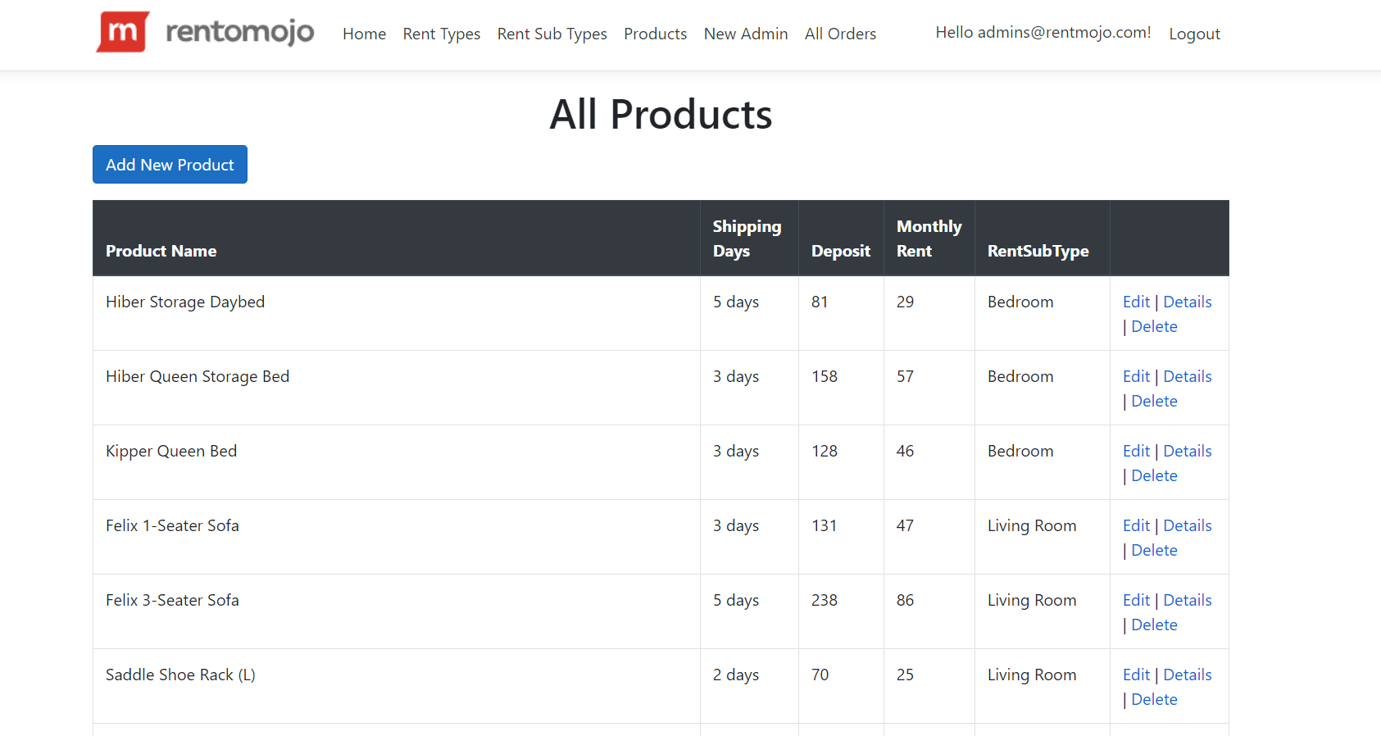

### 

### All Product Page Visitor View

With the help of this page Visitor can view All Product details.

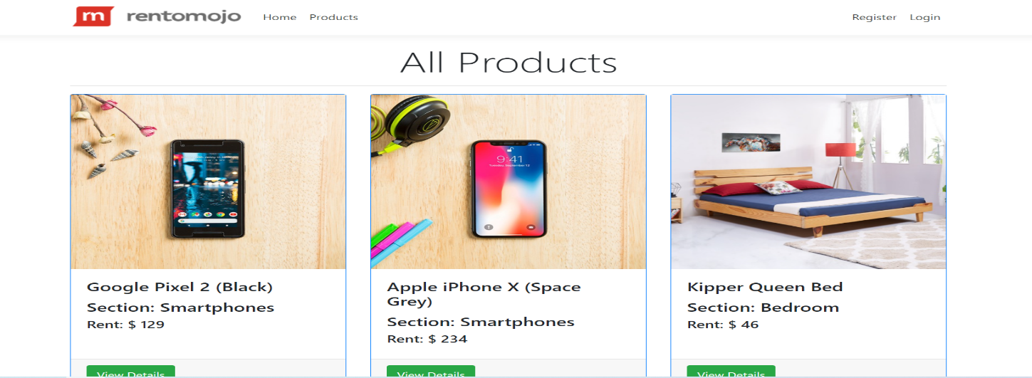

### 

### All Sub Type Visitor View

With the help of this page visitor can check the details of the Sub Types and link to their product.

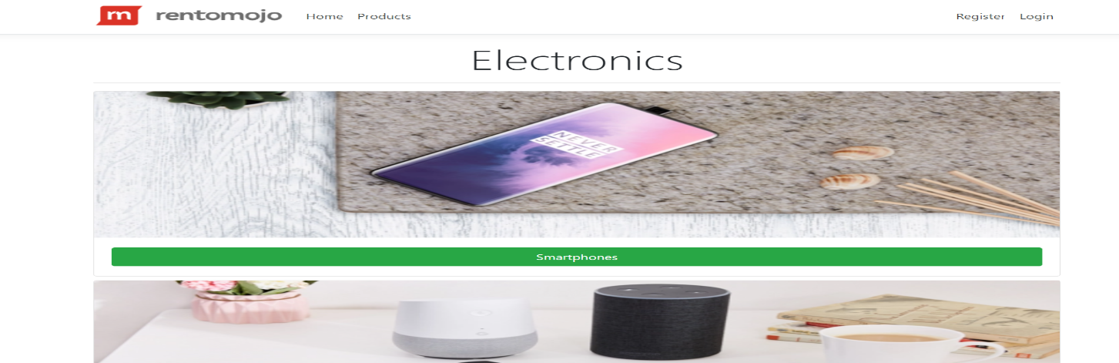

### Product Details Page Customer View

This page shows the Product details and pricing for rent the product.

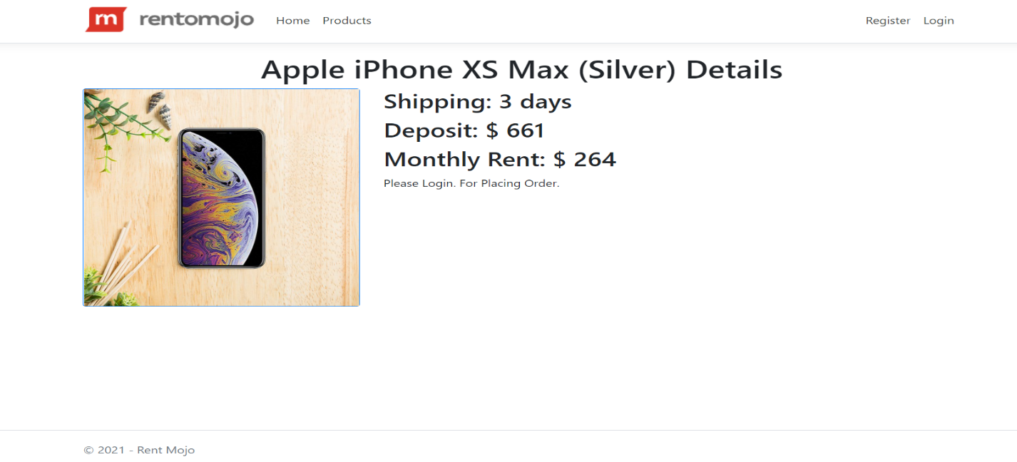

## Project Testing

The testing file for usability testing is attached as [usability test.xlsx](usability%20test.xlsx)

# User Manual

The main purpose of the application Rentomojo is to help people to find daily used items of their choice for rent based upon their choice. In this application there are two types of users- admin and registered user or visitor customer. Admin has different functionalities as compare to customers. Admin can add, edit, delete and check details of types, sub types, and product entries. Also, admin can delete, and access details of the User Orders made by the registered user.

## Summary

### System Configuration

This app will be useful to for distributing mobile information in presentable format.

### User Access Levels

Only registered users can access the features of this application.

* **Admin:** Admin has full access of the app can register new admins.
* **Registered Visitor:** New visitor can register and existing can login using their own credentials. They have limited access.